**CHAPTER 1**

**INTRODUCTION**

* 1. **Need for DBMS?**

Database systems are developed for large amounts of data. When dealing with a huge amount of data, two things require optimization: Storage of data and retrieval of data.

**Storage:** According to the principles of database systems, the data is stored in such a way that it acquires a lot less space as the redundant data (duplicate data) has been removed before storage. Let’s take a layman example to understand this. In a banking system, suppose a customer is having two accounts, one is a saving account and another is a salary account. Let’s say the bank stores saving account data at one place (these places are called tables we will learn them later) and salary account data at another place, in that case, if the customer information such as customer name, address, etc. are stored at both places then this is just a wastage of storage (redundancy/ duplication of data), to organize the data in a better way the information should be stored at one place and both the accounts should be linked to that information somehow. The same thing we achieve in DBMS.

**Fast Retrieval of data:** Along with storing the data in an optimized and systematic manner, it is also important that we retrieve the data quickly when needed. Database systems ensure that the data is retrieved as quickly as possible.

The choice of a database product is often influenced by factors such as:

• the computing platform (i.e., hardware, operating system)

• the volume of data to be managed

• the number of transactions required per second

• existing applications or interfaces that an organization may have

* 1. **Design and Modeling:**

The first task of a database designer is to produce a conceptual data model that reflects the structure of the information to be held in the database. A common approach to this is to develop an entity-relationship model, often with the aid of drawing tools.

Another popular approach is the Unified Modeling Language. A successful data model will accurately reflect the possible state of the external world being modeled: for example, if people can have more than one phone number, it will allow this information to be captured.

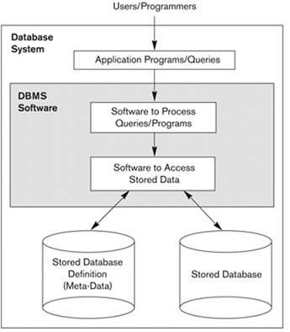

**Figure 1.1 : Simplified database system environment**

**1.3 PROBLEM STATEMENT:**

In the world of software development there lots of improvement in the area of Architectural design and principles. The philosophies and implementation details are changing as the people guiding the development of the application.

Web services are one such area where architects must lean on their creative side and hope that their solutions are still successful. In this report we will explain an exciting voyage down the road of Web services application.

* 1. **OBJECTIVE:**

The aim is to Automate its existing manual system with the help of computerized equipment and full-fledged computer software, fulfilling their requirements, so that their valuable data/information can be stored for a longer period with easy accessing and manipulation of the same. The project describes how to manage for good performance and better services for the clients.

Online Job Portal is a PHP, MySQL-based project, demonstrating the functionalities required to run a job portal. With the advent of the internet applying for jobs and getting a placement has become a hassle-free task.

A job seeker can view thousands of jobs posted by employers and can apply for a job suiting his skills.

Job Portal enables an employer can post a job and can view information of enrolled job seekers, shortlist candidates for an interview and select best in industry candidates.

An Employer can view and download the resume of applicants.

Online job portal project is made up of 3 modules:

1. Administrator
2. Job Provider
3. Job Seeker

With the advent of the internet applying for jobs and getting a placement has become a hassle-free task. Online Job portal is an application developed using HTML, CSS, JavaScript, Php, and MySql technologies which connect employer and job seekers where employers register themselves and post jobs using the system which will be visible to all the site users whether registered or not registered. And the job seekers can find and apply for their targeted job, only the registered job seekers can apply for jobs and view the status of applied jobs.

The employers can view the job seekers' resume who have applied for their posted job and Select or reject the application.

The status of the job application can be viewed by the respective applicant/job seeker.

#### **1.5 Project Modules:**

**1)Administrator**

* Manage the jobseeker section. Like: delete jobseeker
* Admin users can view the jobseeker’s applications for each job.
* Manage complete employer section. Admin user can delete the company and their jobs information.
* Manage whole website content. Dynamic CMS is included to manage the content of the website.

**2)JobProvider Module:**

* New employers can register into the system.
* Create new posts, view a post, modify or delete a post.
* View Applicant's details.
* Download the Applicants resume.
* Accept or reject an application.
* Filter Job seekers based on their Company Requirement and Select

**3)Job Seeker Module :**

* Register into the system, Upload your resume.
* Apply for a job.
* View applied for job status
* Filter jobs based on the job title search

**CHAPTER 2**

**SYSTEM SPECIFICATION**

**HARDWARE & SOFTWARE REQUIREMENT**

**2.1 SOFTWARE REQUIREMENTS:**

Operating system: ANY OS (Recommended: Windows 7 or above)

Web Server: XAMPP

Program editor: Visual Studio Code

Database: MySQL

Browser: Preferable Google Chrome or Mozilla Firefox

Programming Language: HTML , CSS , JavaScript , PHP.

**2.2 HARDWARE REQUIREMENTS**:

CPU: Pentium IV 2.4 GHz or above

Memory (Primary): 512 MB, 1 GB or above

Hard Disk: 40 GB, 80GB, 160GB or above

Monitor: 15 VGA

**2.3 Visual Studio Code**

Visual Studio Code is a free source-code editor made by Microsoft for Windows, Linux, and macOS. Features include support for debugging, syntax highlighting, intelligent code completion, snippets, code refactoring, and embedded Git.

**2.4 XAMPP:**

XAMPP is a free and open-source cross-platform web server solution stack package developed by Apache Friends, consisting mainly of the Apache HTTP Server, MariaDB database, and interpreters for scripts written in the PHP and Perl programming languages.

XAMPP stands for Cross-Platform (X), Apache (A), MariaDB (M), PHP (P), and Perl(P).

It is a simple, lightweight Apache distribution that makes it extremely easy for developers to create a local web server for testing and deployment purposes. Everything needed to set up a web server – server application (Apache), database (MariaDB), and scripting language (PHP) – is included in an extractable file.

**2.5 Browser**:

Google Chrome is preferably used to run the webserver locally. "Localhost" refers to the local computer that a program is running on. Localhost is used in Web scripting languages like PHP, for defining the Apache server the code should run from or where the online job portal database is located.

**CHAPTER 3**

**SYSTEM DESIGN**

**3.1 ER Diagram:**

An Entity Relationship model , also called an entity-relationship (ER) diagram, is a graphical representation of entities and their relationships to each other, typically used in computing regarding the organization of data within databases or information systems. An entity is a piece of data an object or concept about which data is stored.

The cardinality or fundamental principle of one data aspect with respect to another is a critical feature. The relationship of one to the other must be precise and exact between each other to explain how each aspect links together. In simple words, Cardinality is a way to define the relationship between two entities.

**The following are the notations of the ER diagram:**

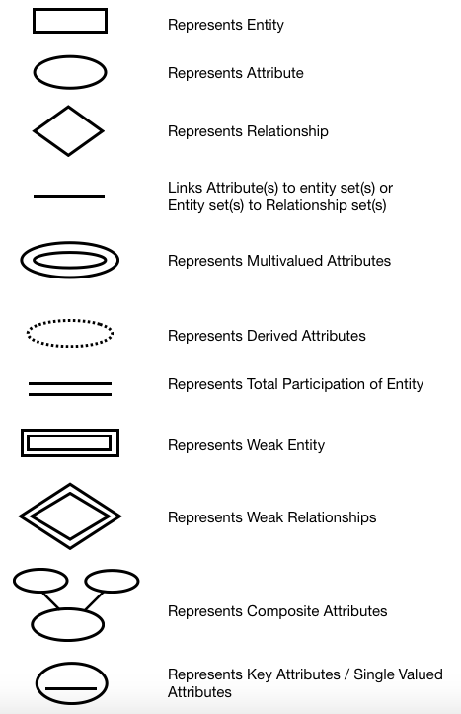

**Below is the ER Diagram of JobAlert.in:**

Table 1.1

**1**

**view**

**Contact_messages**

**admin**

**M**

**1**

**1**

**manages**

**manages**

**M**

**M**

**company**

**user**

**1 1**

**apply**

**post**

**M**

**job**

**M**

**user_applied_job**

**3.2 Schema Diagram**:

In any data model it is important to distinguish between the description of the database and the database itself.

The description of a database is called the database schema, which is specified during database design and is not expected to change frequently. A displayed schema is called a schema diagram.

A schema diagram displays only some aspects of a schema, such as the names of record types and data items, and some types of constraints.

**admin_db**

|  |  |  |
| --- | --- | --- |
| **admin_id** | **admin_name** | **admin_password** |

**comp_db**

|  |  |  |  |  |  |
| --- | --- | --- | --- | --- | --- |
| **comp_id** | **comp_name** | **comp_about** | **comp_address** | **comp_email** | **comp_password** |

**Job_db**

|  |  |  |  |  |  |  |  |
| --- | --- | --- | --- | --- | --- | --- | --- |
| **job_id** | **comp_id** | **job_name** | **job_about** | **job_address** | **job_skills** | **job_salary** | **job_qualification** |

**User_db**

|  |  |  |  |  |  |  |  |  |  |
| --- | --- | --- | --- | --- | --- | --- | --- | --- | --- |
| **user_id** | **user_name** | **user_gender** | **user_email** | **user_number** | **user_address** | **user_about** | **user_skills** | **user_resume** | **user_password** |

**User_applied_job_db**

|  |  |  |  |  |  |  |
| --- | --- | --- | --- | --- | --- | --- |
| **User_applied_job_id** | **User_id** | **Job_id** | **Comp_id** | **Job_name** | **Comp_name** | **status** |

**Contact_db**

|  |  |  |  |  |
| --- | --- | --- | --- | --- |
| **contact_id** | **contact_name** | **contact_email** | **contact_mobile** | **contact_message** |

Table 1.2

**CHAPTER 4**

**FUNCTIONS**

**4.1 MYSQL DATABASE**

In this project, MySQL is used as the backend database. MySQL is an open-source database management system.

**The features of MySQL are given below**:

* **Easy to use:** MySQL is easy to use. You have to get only the basic knowledge of SQL. You can build and interact with MySQL with only a few simple SQL statements.
* **It is secure:** MySQL consists of a solid data security layer that protects sensitive data from intruders. Passwords are encrypted in MySQL.

* **Client/ Server Architecture:** MySQL follows a client /server architecture. There is a database server (MySQL) and arbitrarily many clients (application programs), which communicate with the server; that is, the query data, save changes, etc.
* **Free to download:** MySQL is free to use and you can download it from MySQL's official website.
* **It is scalable:** MySQL can handle almost any amount of data, up to as much as 50 million rows or more. The default file size limit is about 4 GB. However, you can increase this number to a theoretical limit of 8 TB of data.
* **Compatible - on many operating systems:** MySQL is compatible to run on many operating systems, like Novell NetWare, Windows * Linux*, many varieties of UNIX*, OS/2, FreeBSD*, and others.
* **Allows roll-back:** MySQL allows transactions to be rolled back, commit, and crash recovery. o High Performance: MySQL is faster, more reliable, and cheaper because of its unique storage engine architecture.
* **High Flexibility:** MySQL supports a large number of embedded applications which makes MySQL very flexible.
* **High Productivity:** MySQL uses Triggers, Stored procedures, and views which allows the developer to give higher productivity.

**The drawbacks of MySQL are given below:**

* MySQL version less than 5.0 doesn't support ROLE, COMMIT, and stored procedure.
* MySQL does not support a very large database size as efficiently.
* MySQL doesn't handle transactions very efficiently and it is prone to data corruption.
* MySQL is accused that it doesn't have a good developing and debugging tool compared to paid databases.
* MySQL doesn't support SQL check constraints

**4.2 Integrating the Website and Database :**

This web application is to be conceived in its current form as dynamic site-requiring constant updates of data both from the job seekers as well as the Job Providers. So a well-organized database is essential for the development and maintenance of an Online Job portal site.

In a static Web page, content is determined at the time when the page is created. As users access a static page, the page always displays the same information. An example of a static Web page is the page displaying company information. In a dynamic Web page, the content varies based on user input and data received from external sources. We use the term “data-based Web pages” to refer to dynamic Web pages deriving some or all of their content from data files or databases.

A data-based Web page is requested when a user clicks a hyperlink or the submit button on a Web page form. If the request comes from clicking a hyperlink, the link specifies either a Web server program or a Web page that calls a Web server program.

In some cases, the program performs a static query, such as “Display all items from the Inventory”. Although this query requires no user input, the results vary depending on when the query is made. If the request is generated when the user clicks a form’s submit button, instead of a hyperlink, the Web server program typically uses the form inputs to create a query.

**4.3 JobAlert.in Application:**

The objective of the project is to enable jobseekers to place their resumes and find appropriate jobs while companies publish their vacancies and find good candidates.

It enables jobseekers to post their resume, search for jobs, View applied jobs lists. It will provide various companies to place their vacancy profile on the site and also have an option to search candidate resumes.

**CHAPTER 5**

**MODULES OF JOBALERT.IN**

**The main modules in this site are**:

1. Administrator
2. Job Seeker
3. Job Provider

**Administrator feature :**

* Manage the jobseeker section. Like: delete jobseeker
* Admin users can view the jobseeker’s applications for each job.
* Manage complete employer section. Admin user can delete the company and their jobs information.
* Manage whole website content. Dynamic CMS is included to manage the content of the website.

**Job Providers Features :**

After registration job provider can perform the following action

* Add / Edit company’s profile
* Post new job vacancies
* Edit / Delete posted jobs
* Job provider can see the list of job seekers who have applied for the job
* Job provider can search for jobseekers
* Job provider can see and download the jobseeker’s resume
* Job provider can send Status to any job seeker

**Job Seekers Features :**

After registration job seeker can perform the following actions:

* Search for jobs
* Apply Online for the desired job
* Add/Edit profile information including qualification, experience, and skills.
* Upload the latest resume.

**Main Website :**

From the main website, the user can perform the following actions:

* Search jobs based on skills, city, country, or job title
* Register as a job seeker or as a job provider
* Login to jobseeker or job provider portal
* About Us
* Contact us
* Recent Jobs

**CHAPTER 6**

**SNAPSHOTS**

Figure 6.1 : Home Page



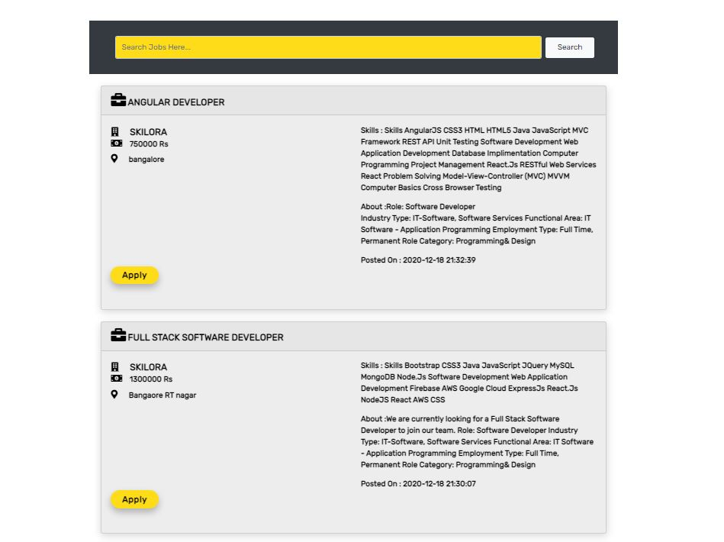

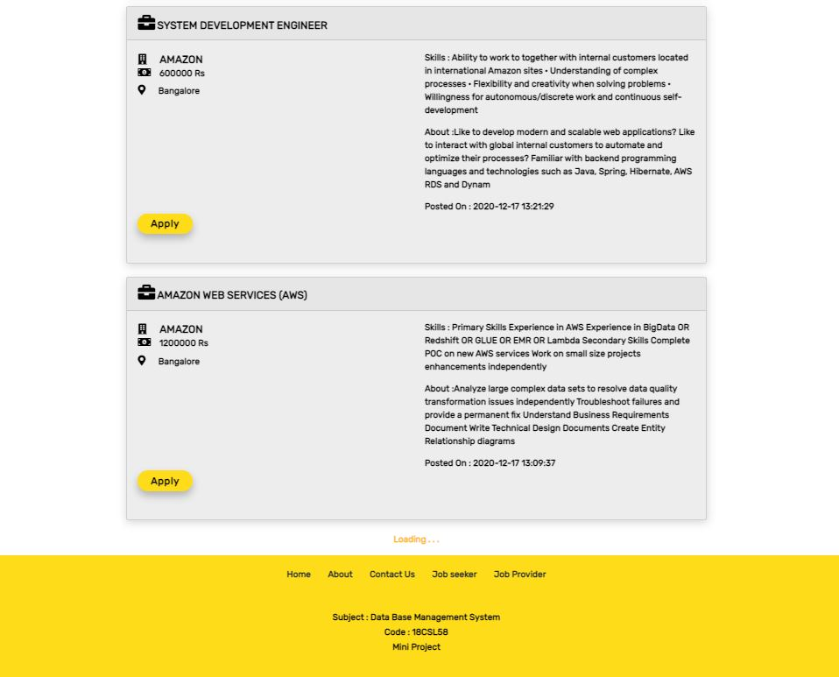

Figure 6.2 : Search Page

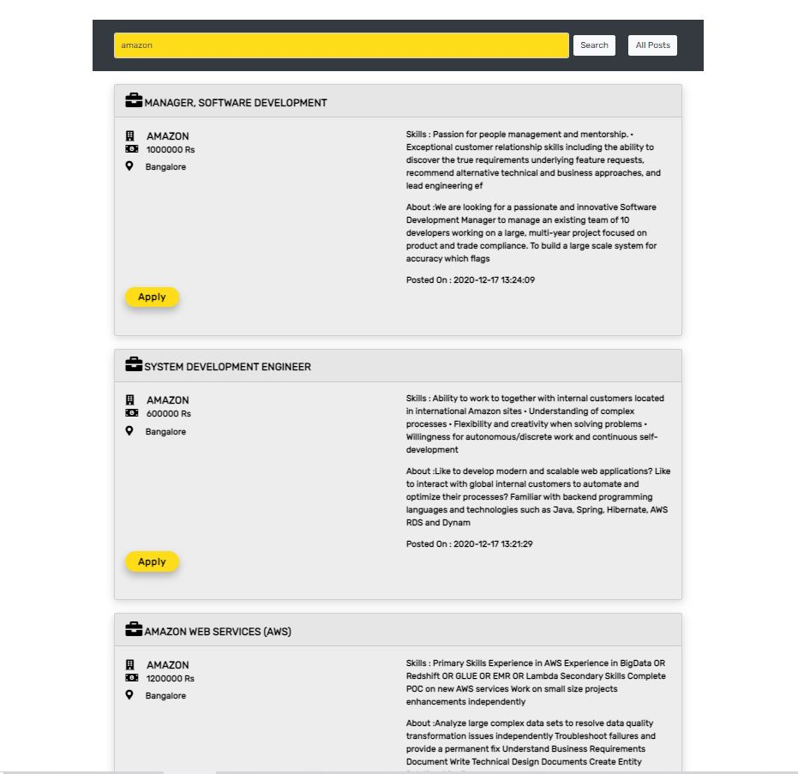

Figure 6.3 : Job Provider Login Page



Figure 6.4 : Job Seeker Login Page



Figure 6.5 : Contact Us Page

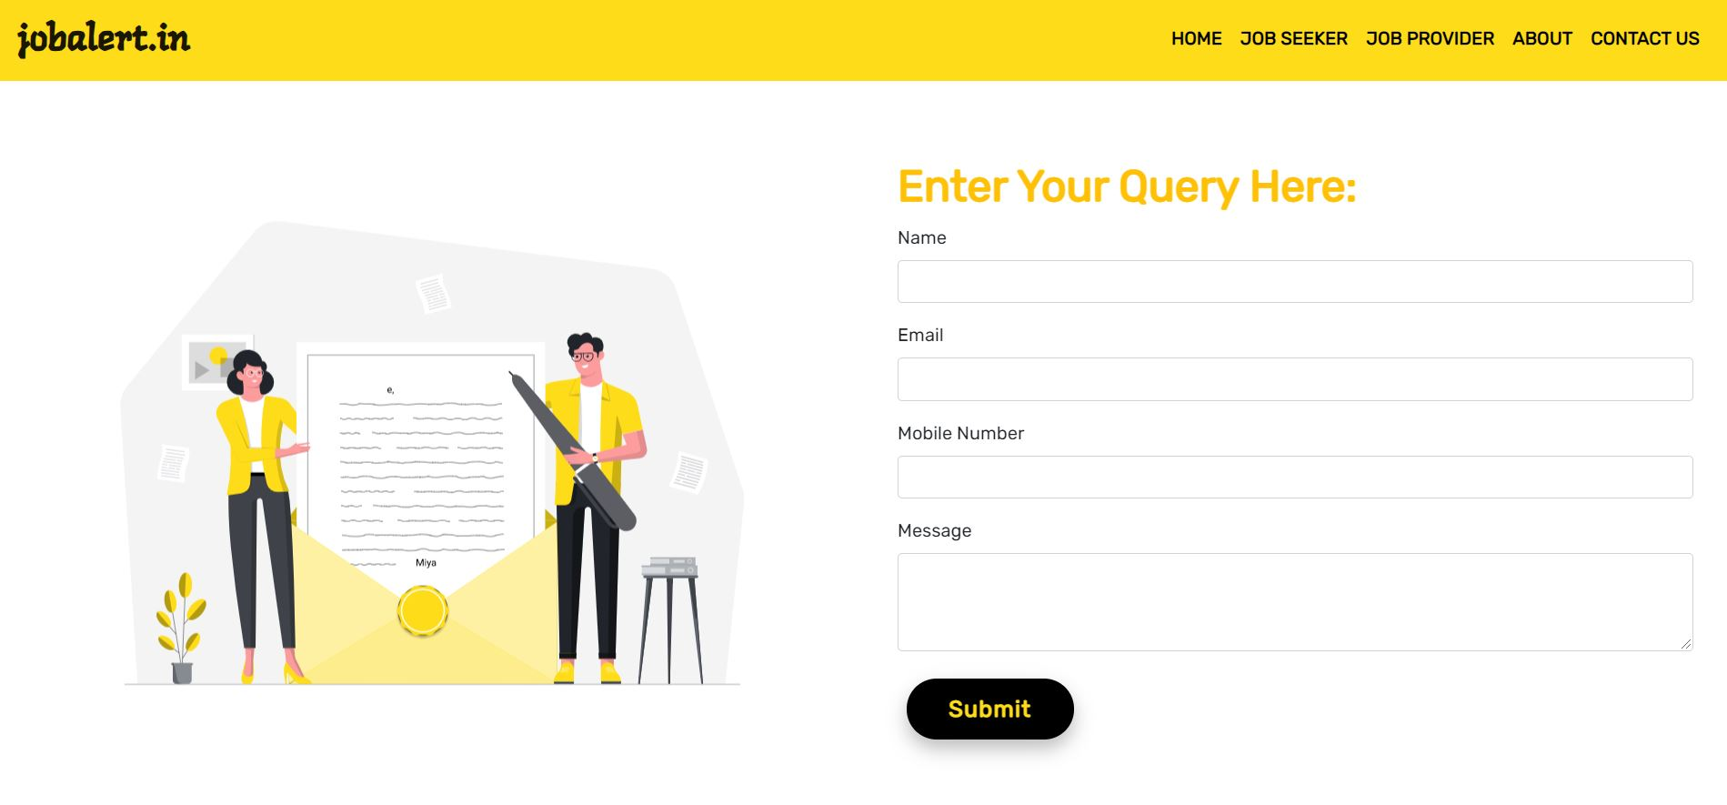

Figure 6.6 : Admin Login



Figure 6.7 : Admin DashBoard

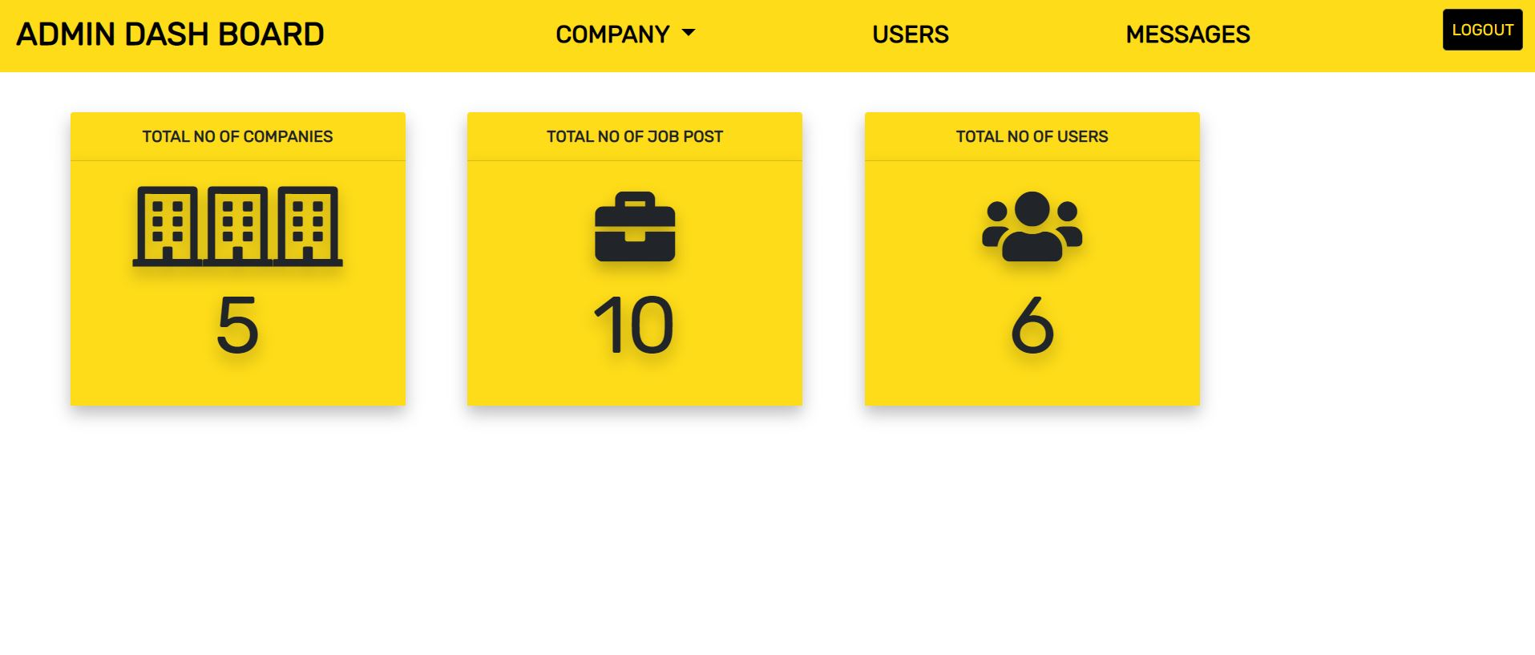

Figure 6.8 : Company Details

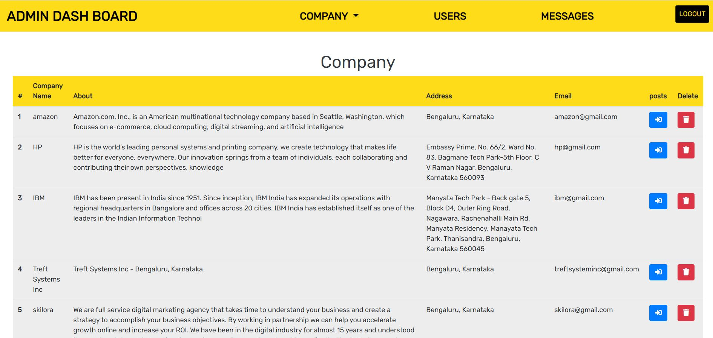

Figure 6.9 : Job Details

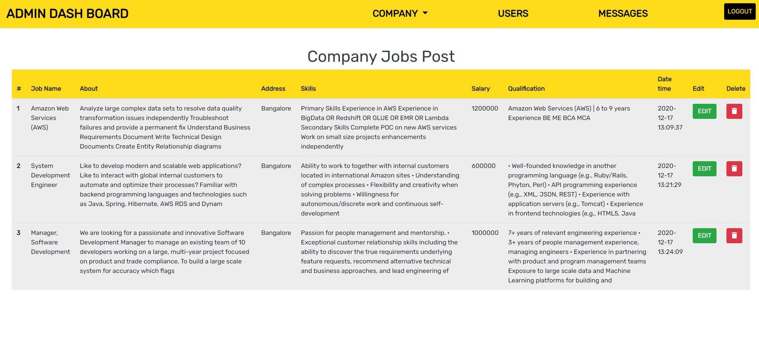

Figure 6.10 : User Details

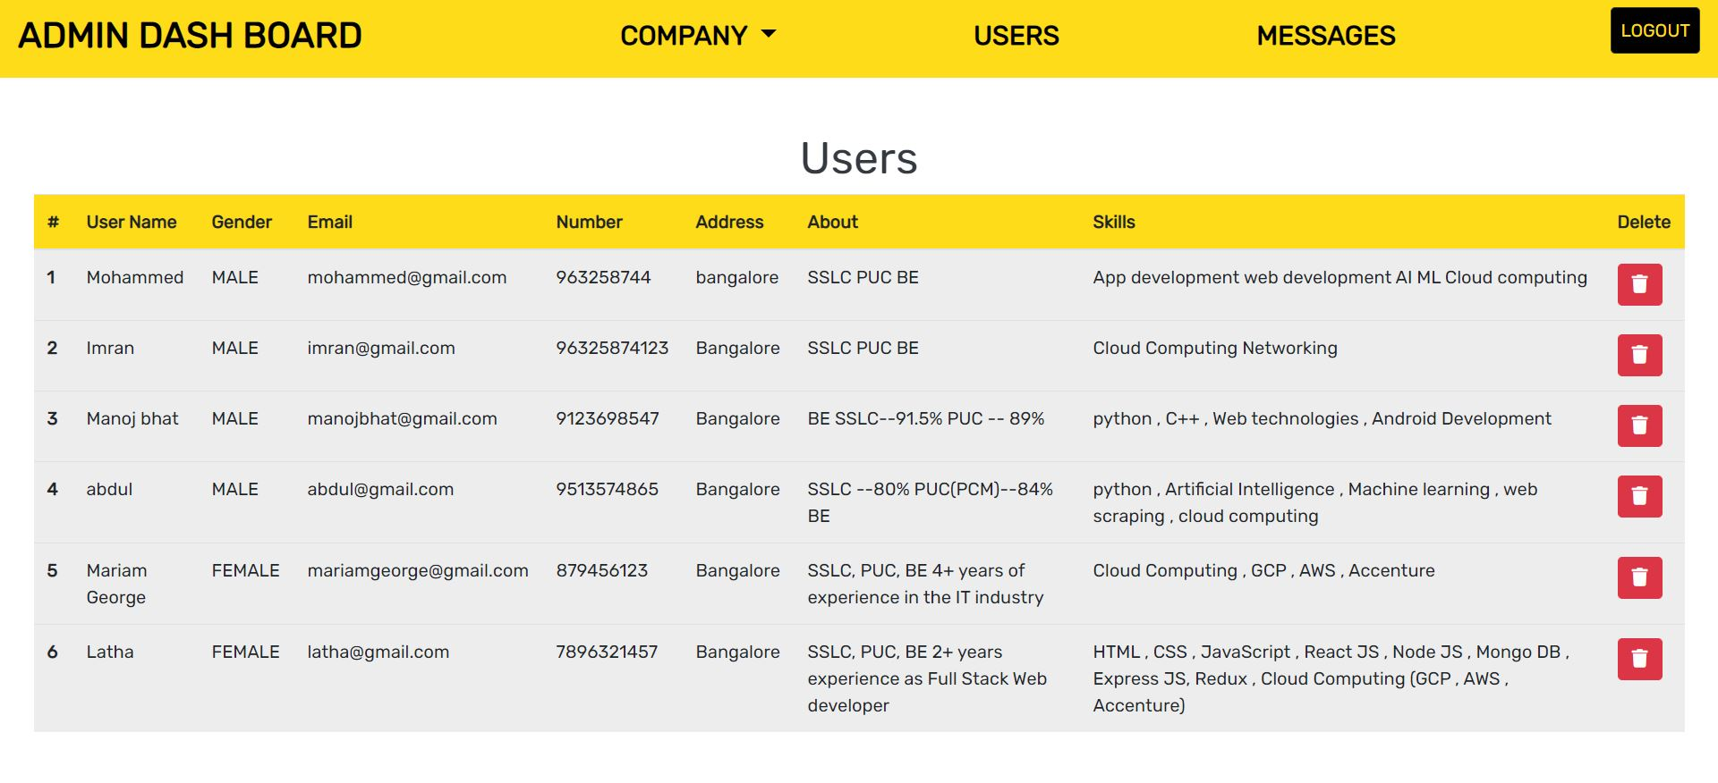

Figure 6.11 : Message Page

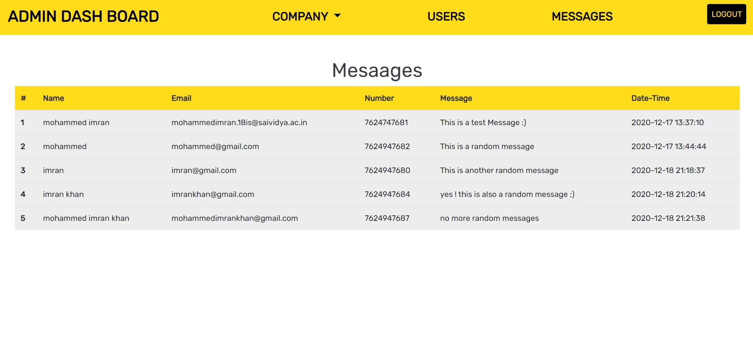Figure 6.12 : Company Registration Page

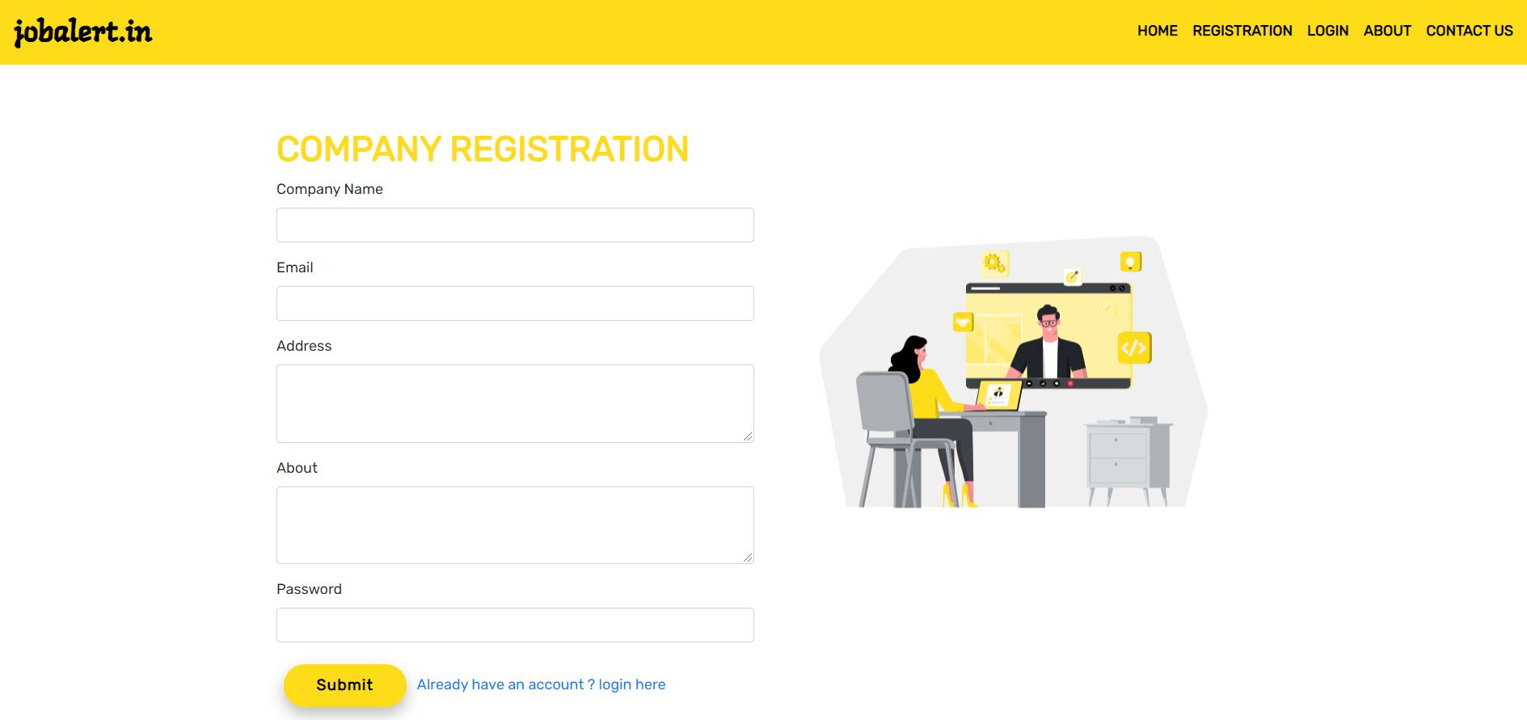

Figure 6.13 : Company Login Page

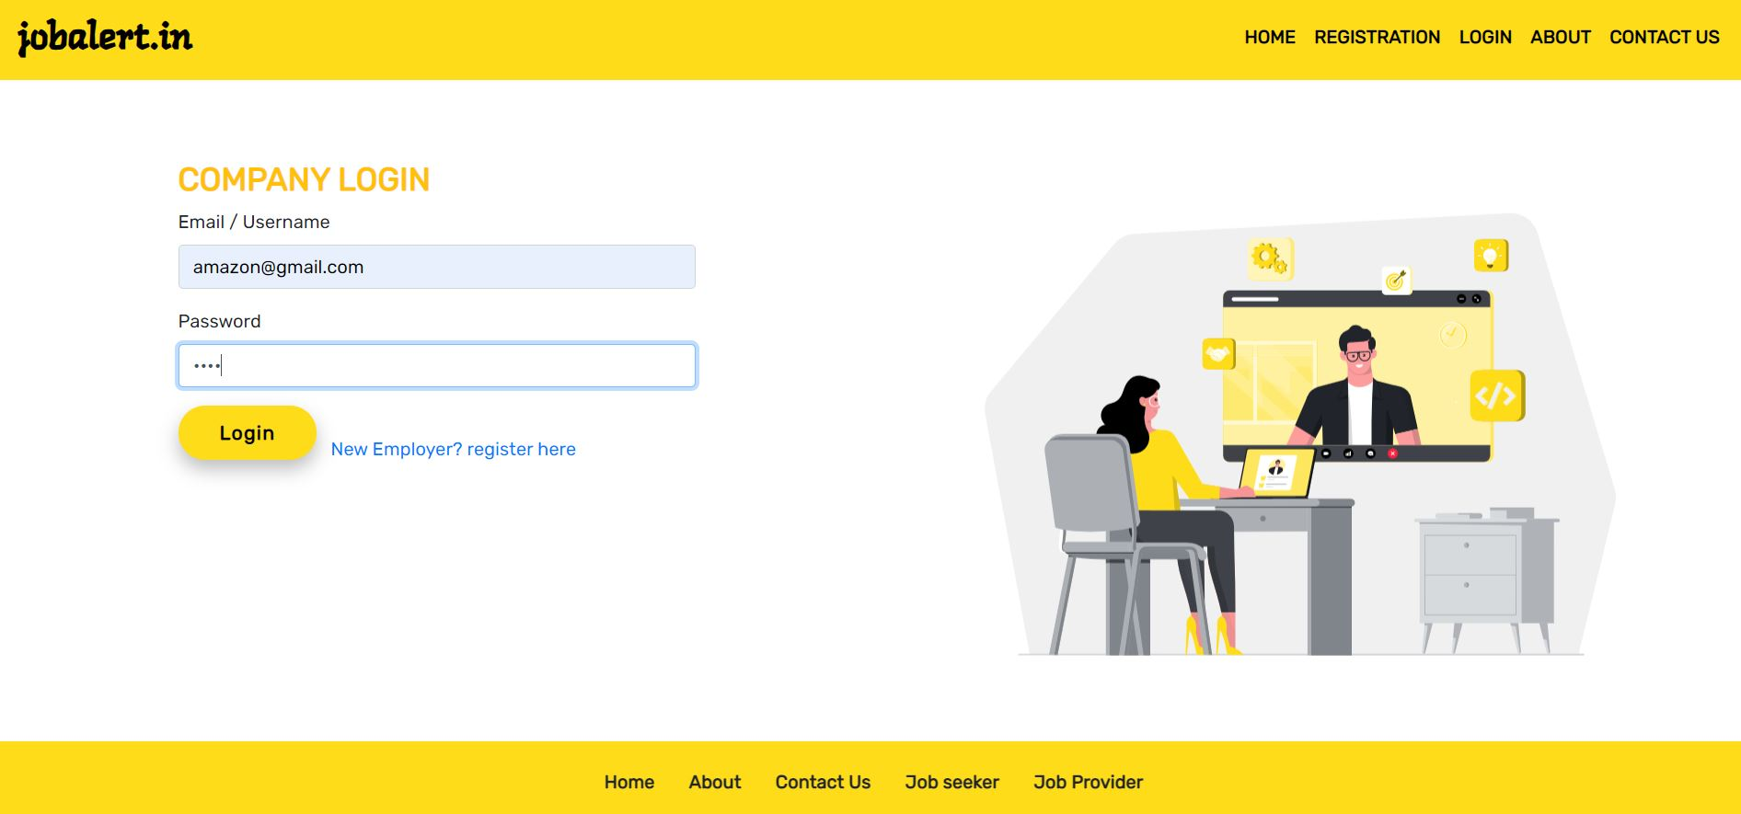

Figure 6.14: Company Login Validation

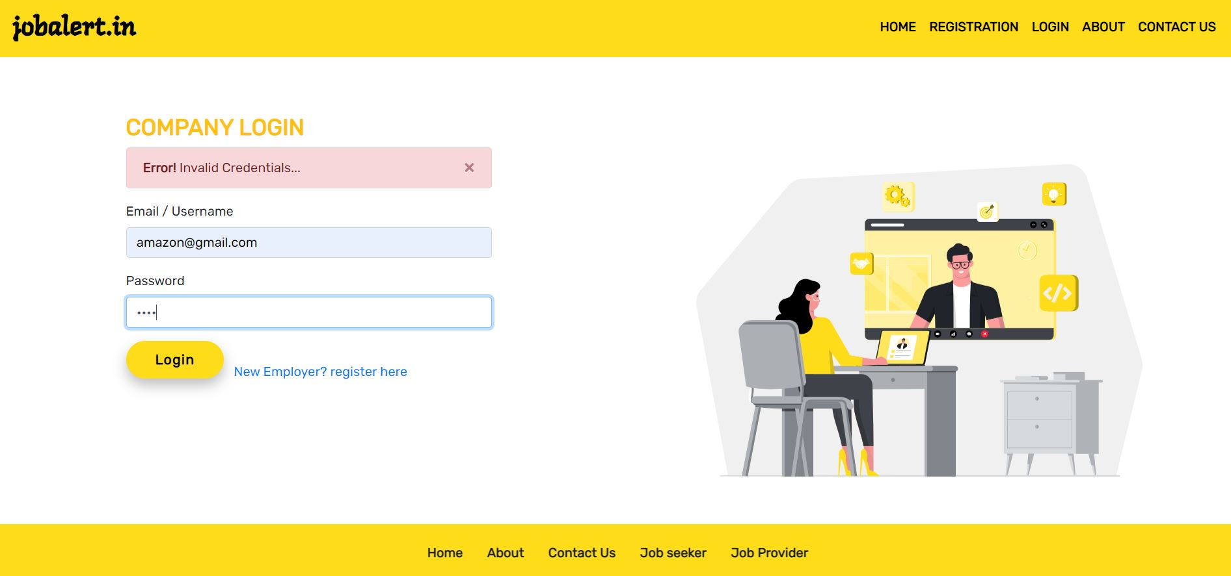

Figure 6.15 : Company Home Page

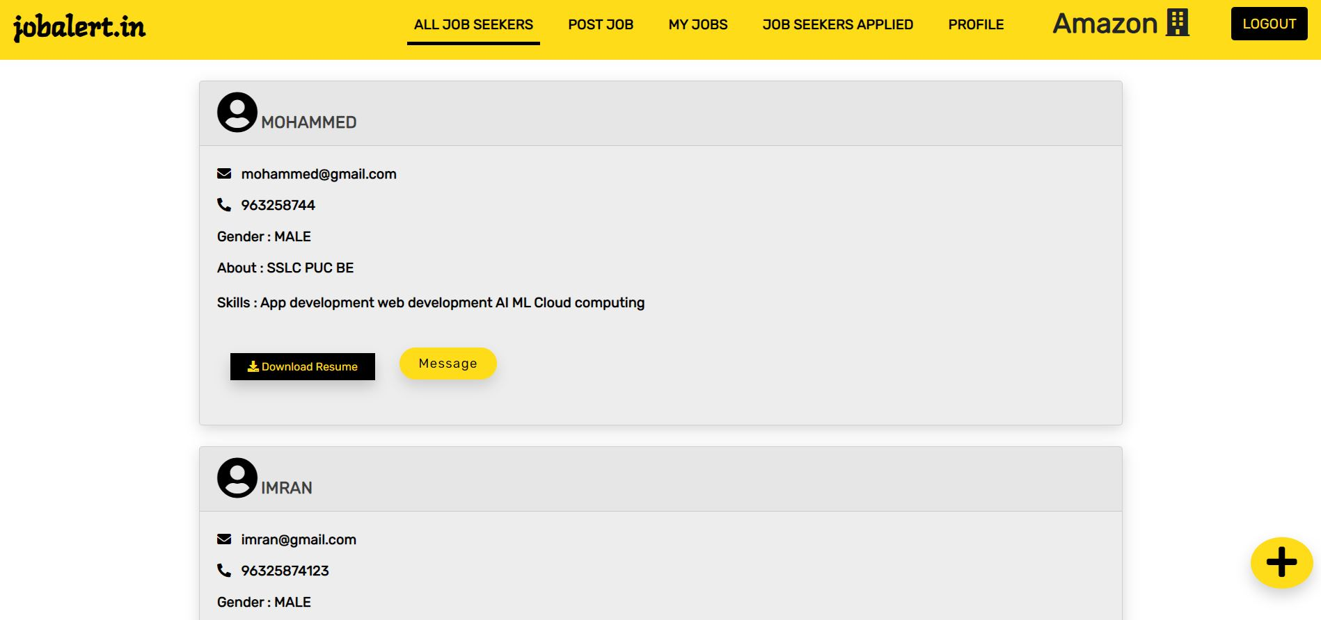

Figure 6.16 : Post New Job

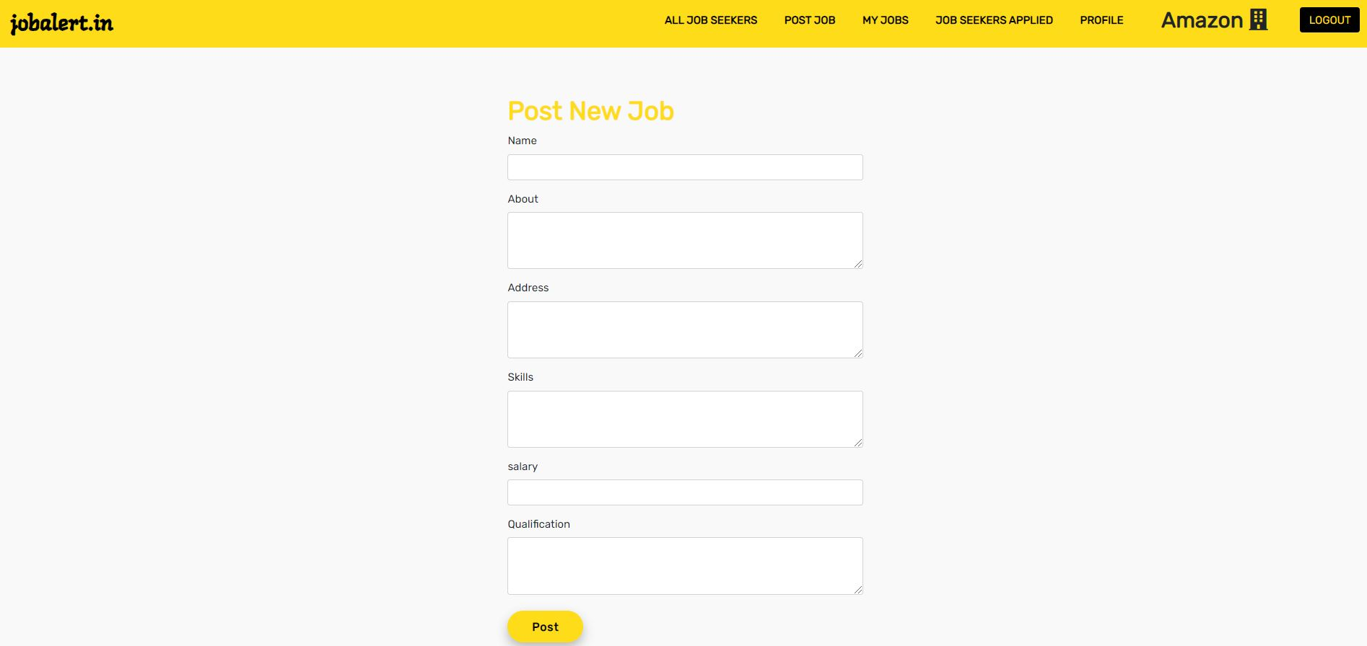

Figure 6.17 : Jobs Post By Company

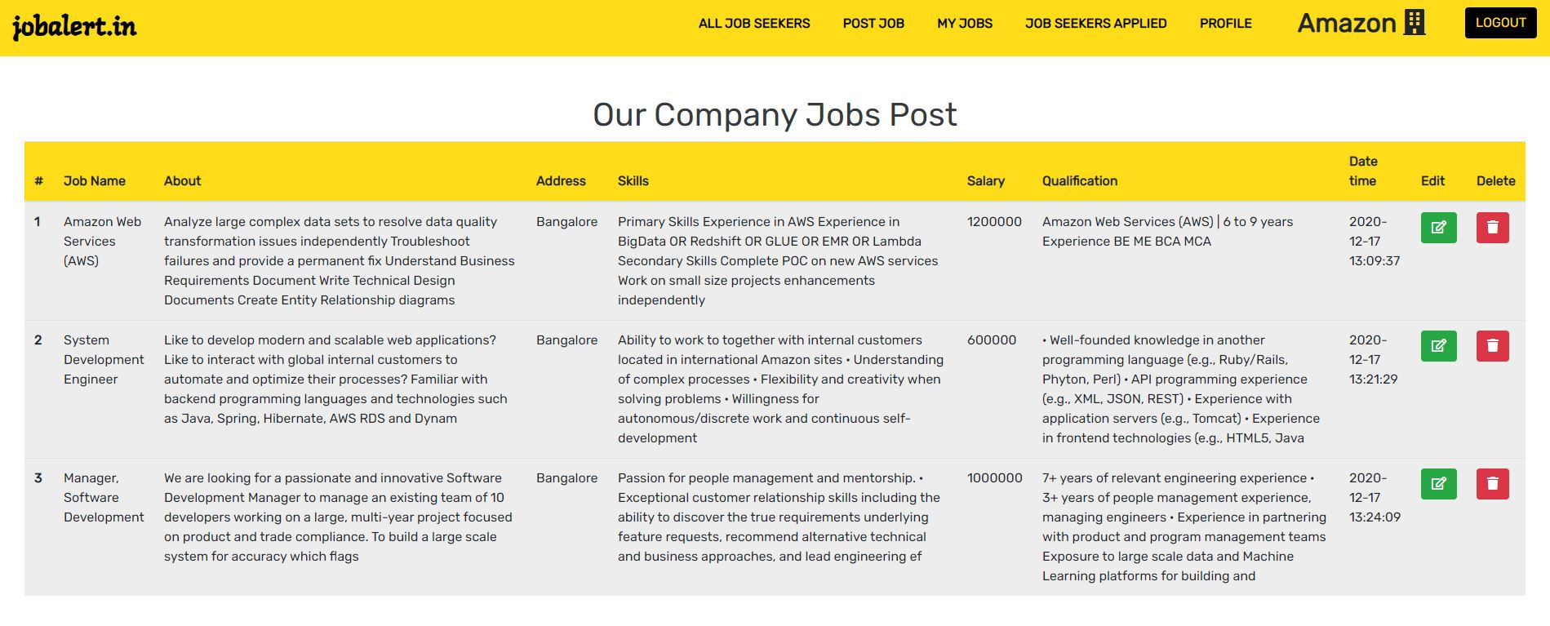

Figure 6.18 : Users Applied To their Company Jobs

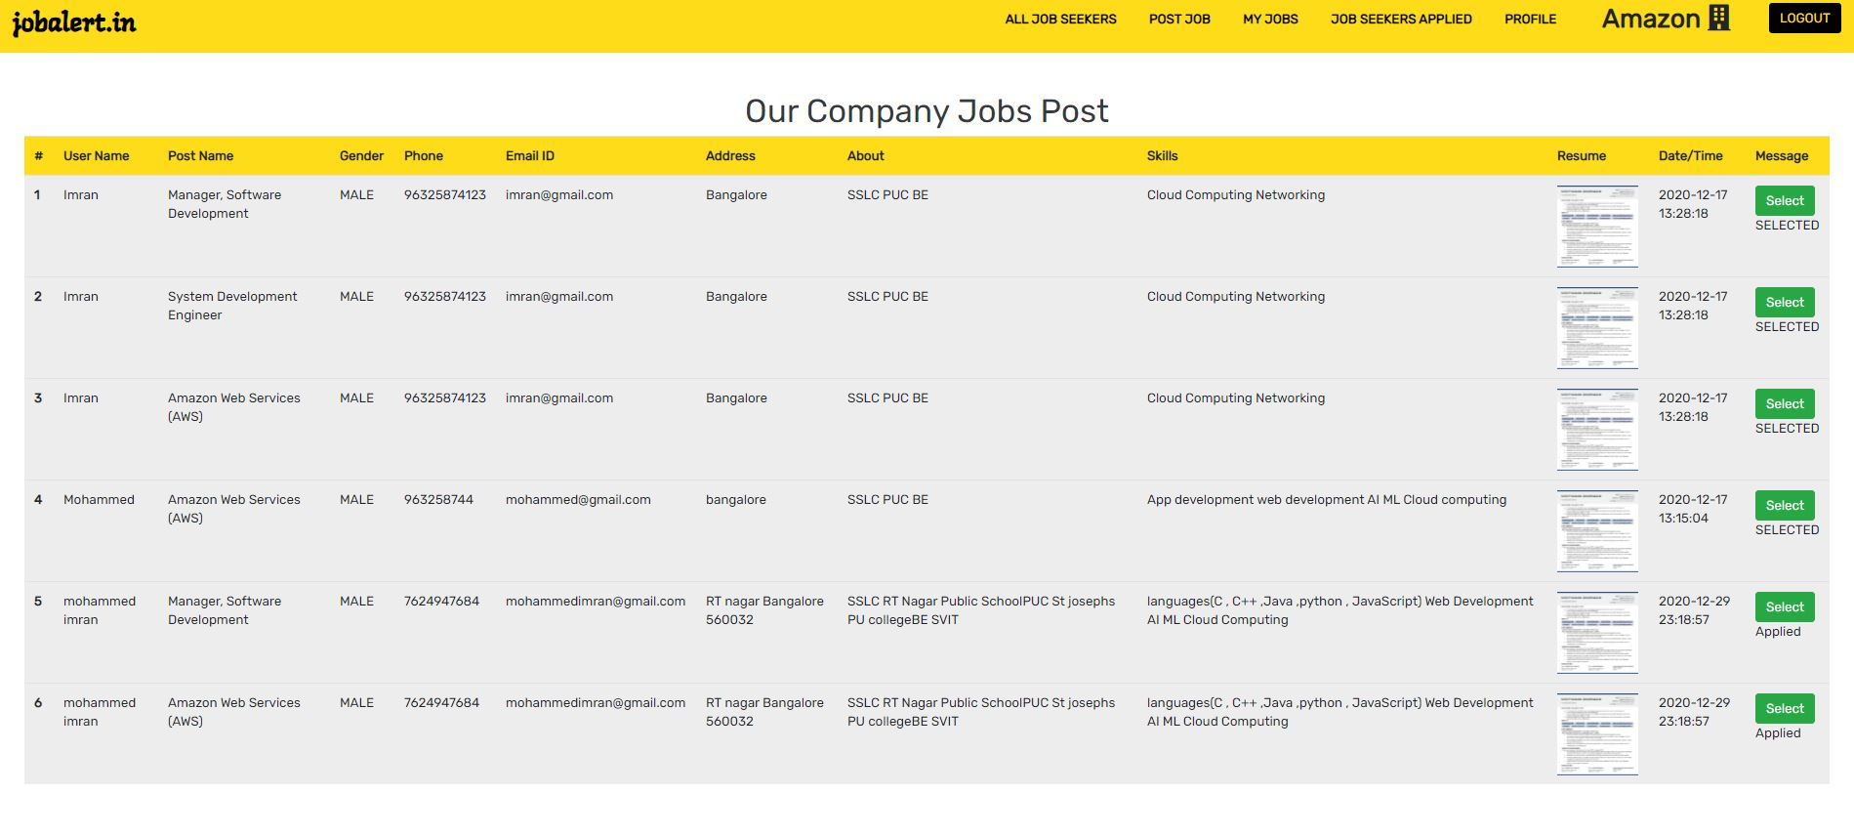

Figure 6.19 : User Applied Jobs

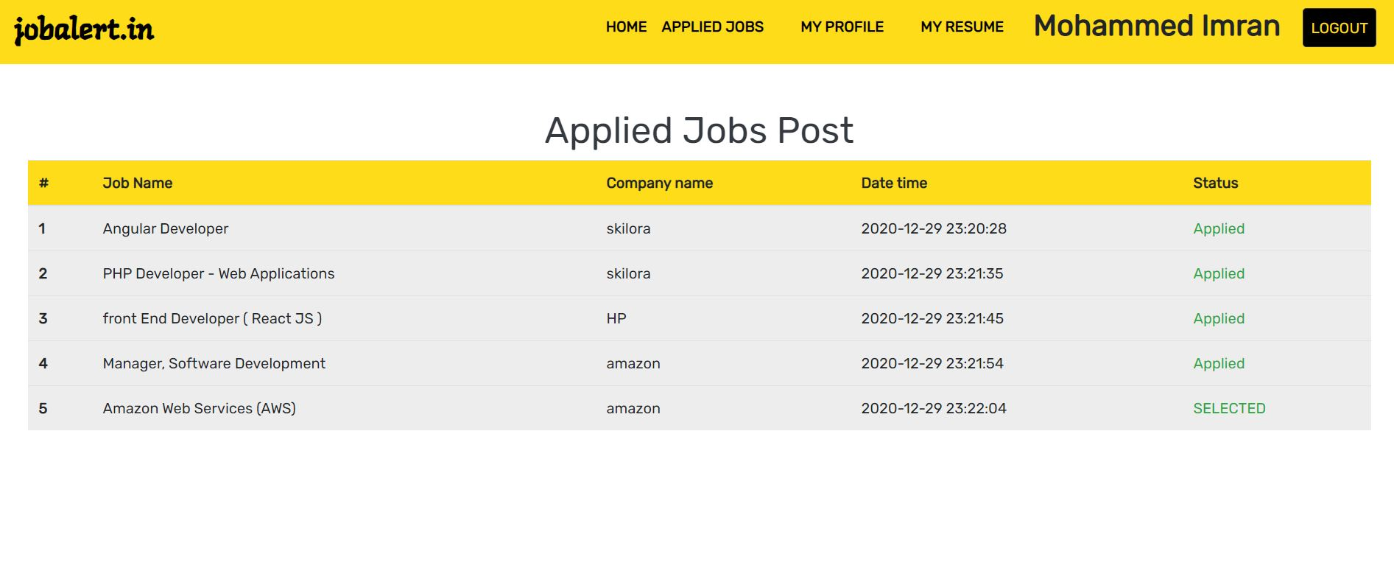

Figure 6.20 : Company Profile Update

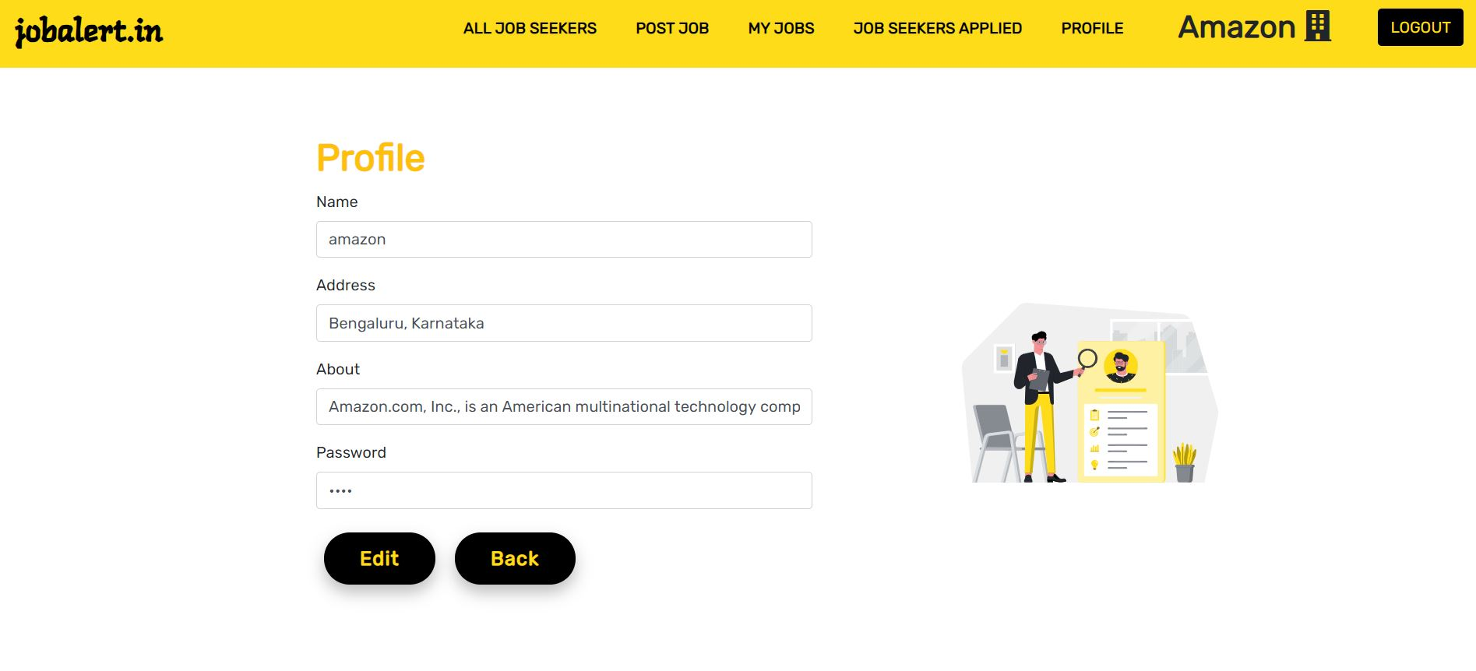

Figure 6.21 : User Registration Page

–––––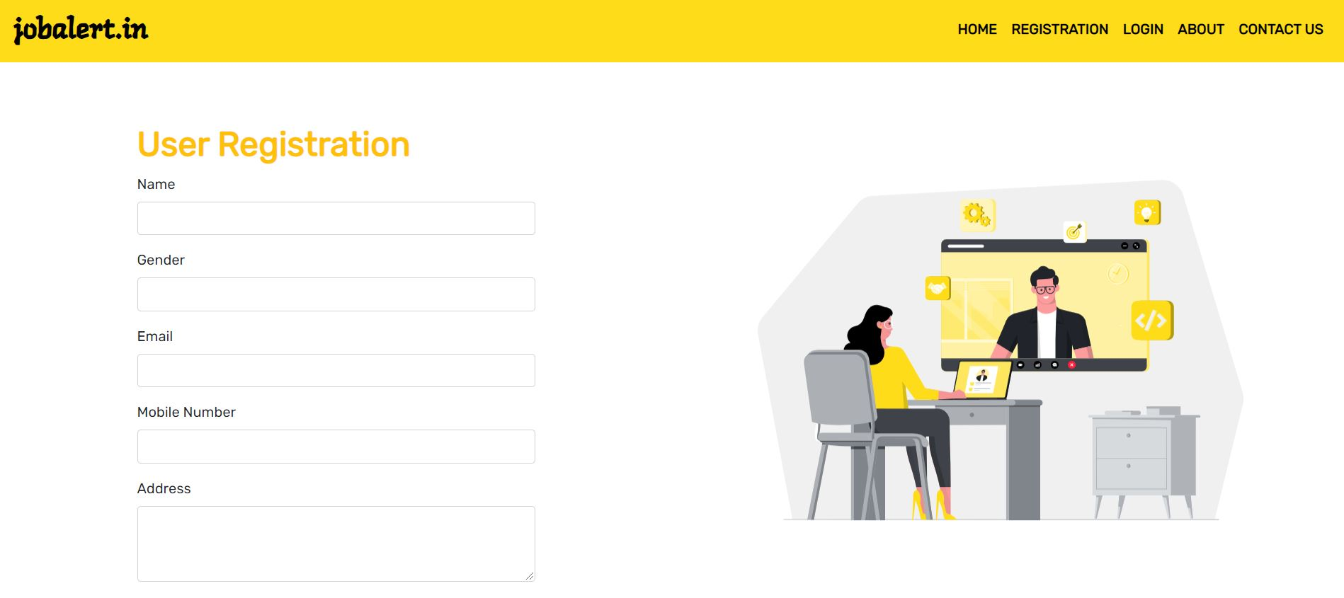

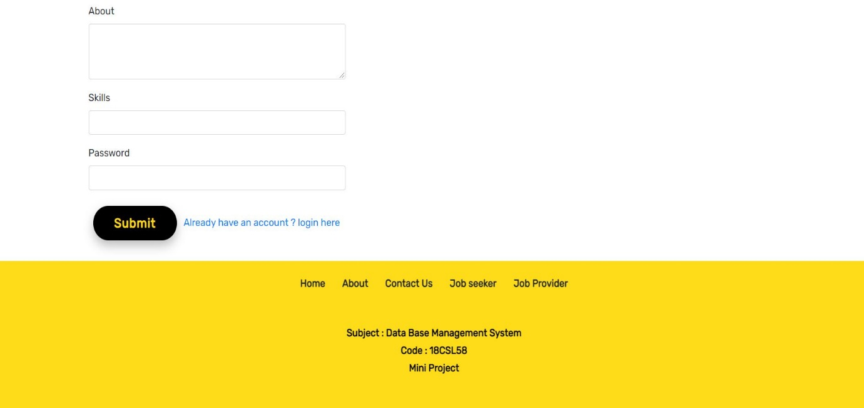

Figure 6.22 : User Login Page

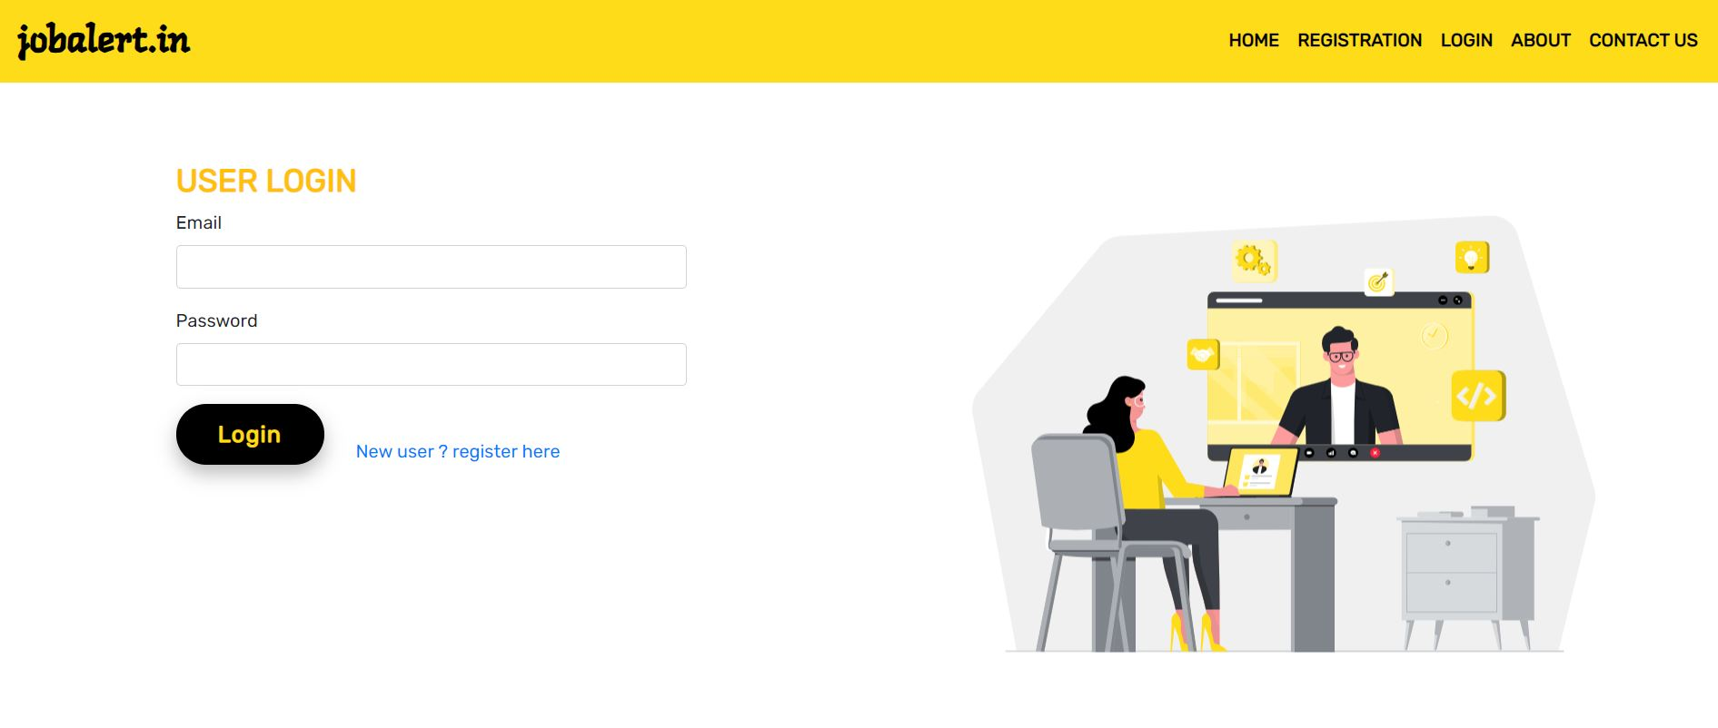

Figure 6.23 : User Home Page

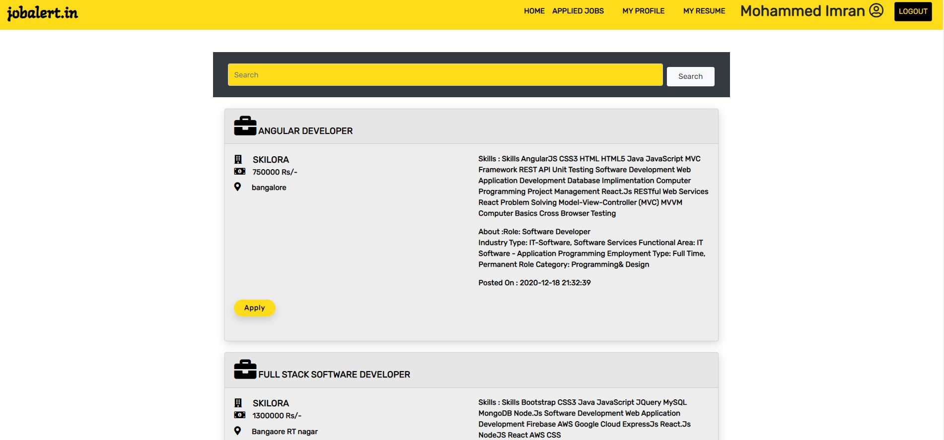

Figure 6.24 : Successfully applied for the Job



Figure 6.25 : Already Applied for the Job



Figure 6.26 : User Applied Jobs and its status

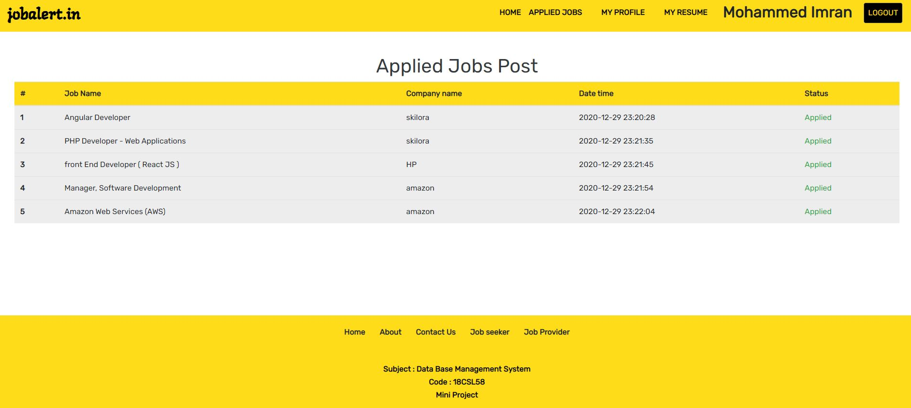

Figure 6.27 : User Profile Update

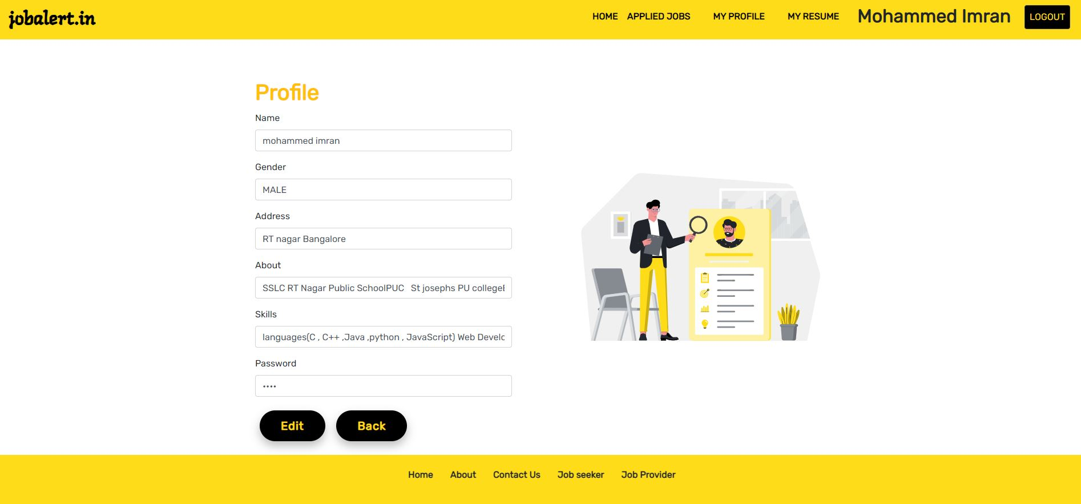

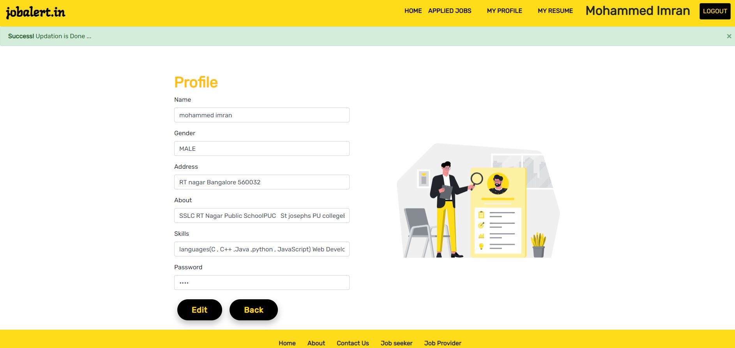

Figure 6.28 : Resume Upload

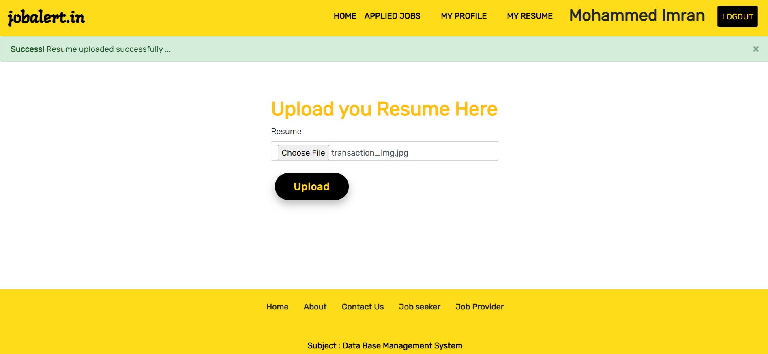

Figure 6.29 : Job Posts

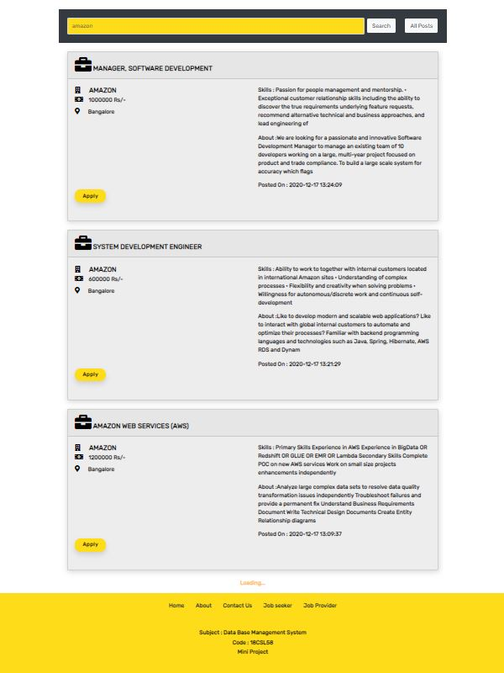

Figure 6.3 : DATABASES

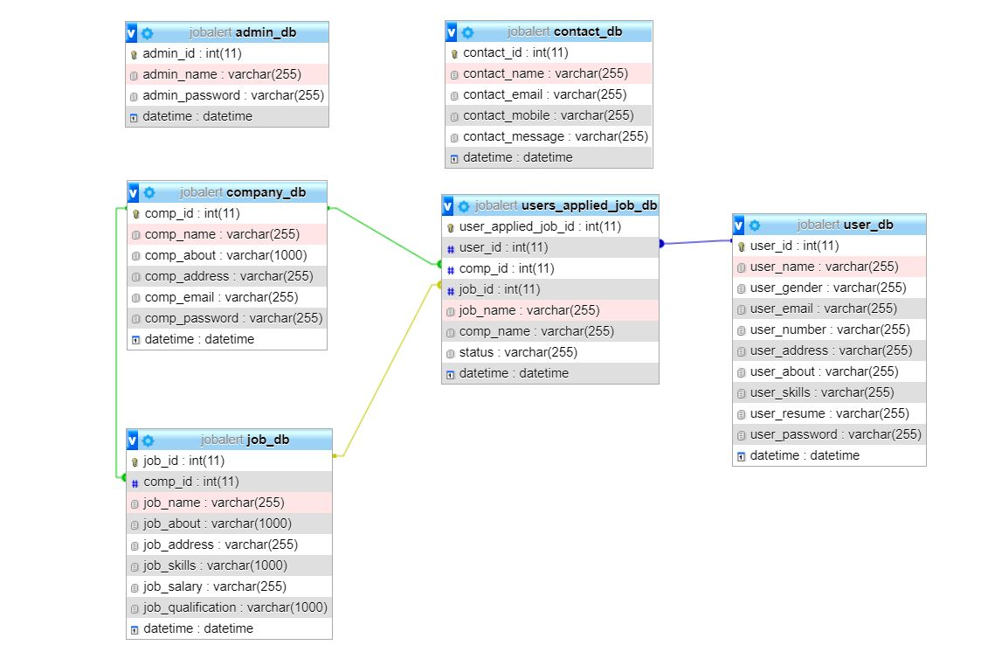

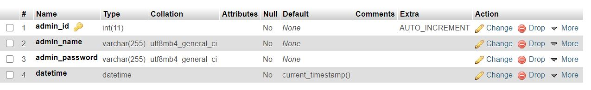

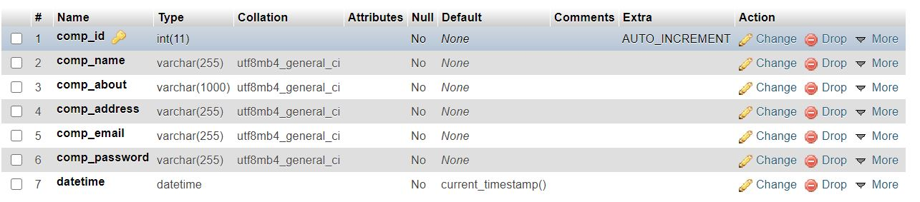

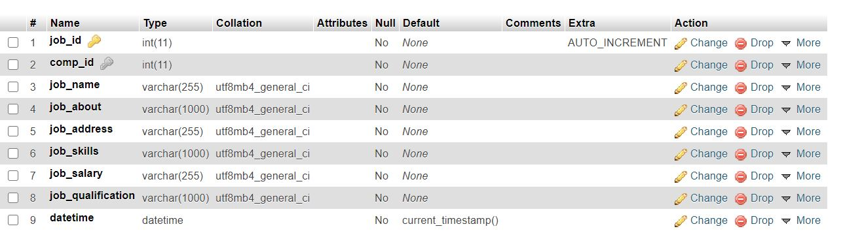

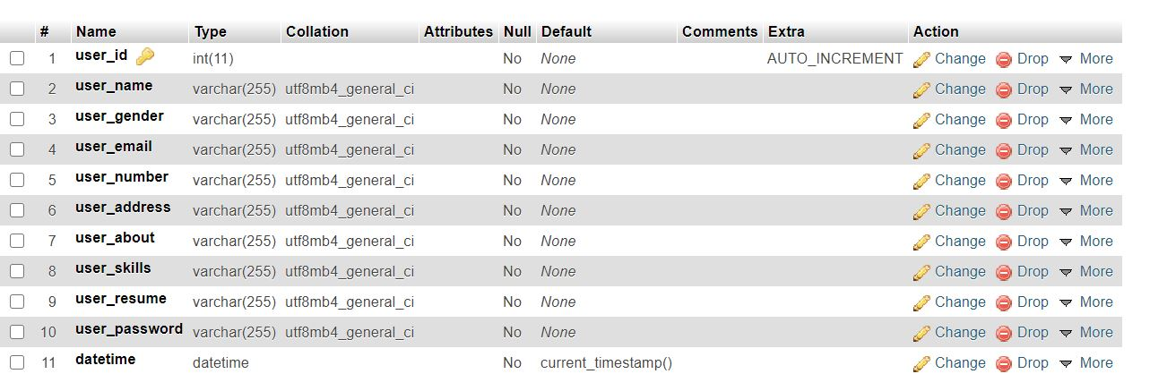

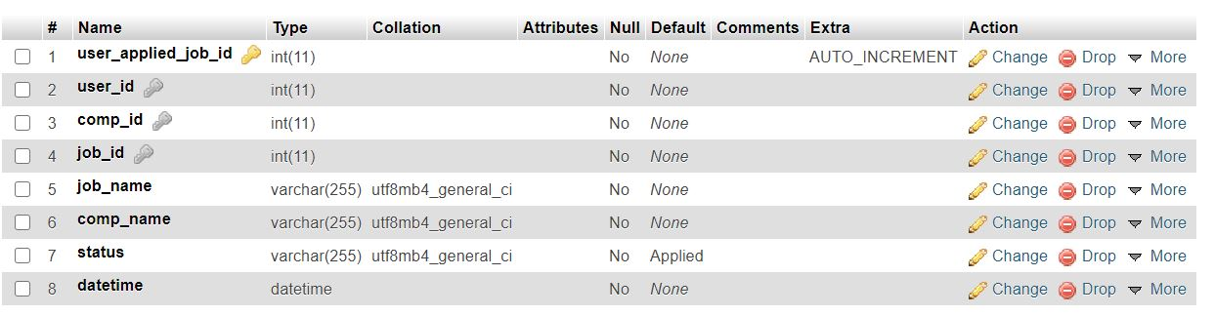

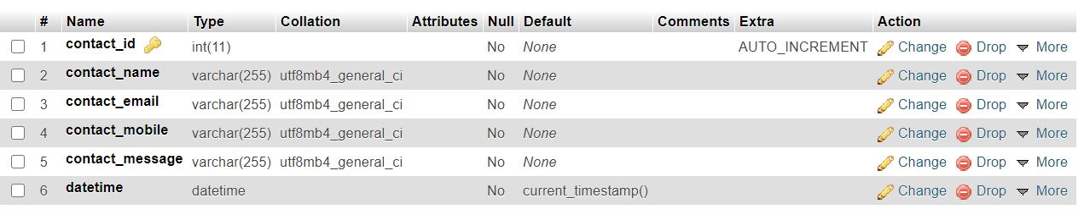

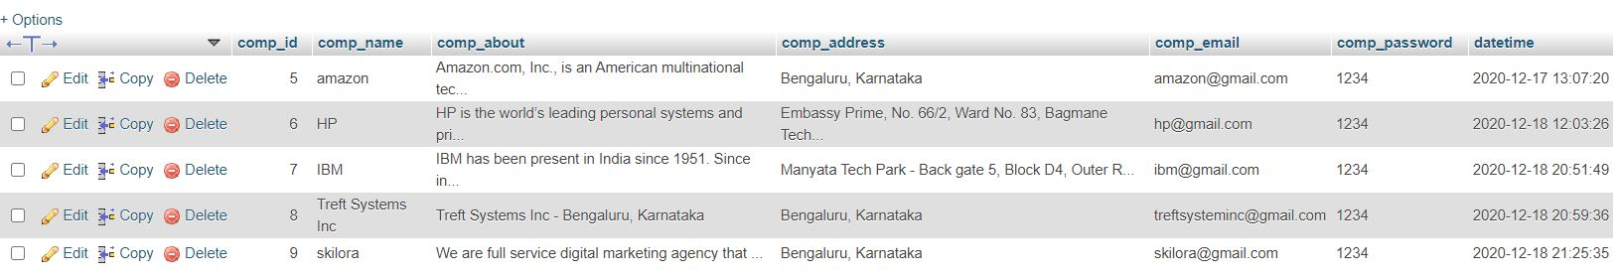

Company DB

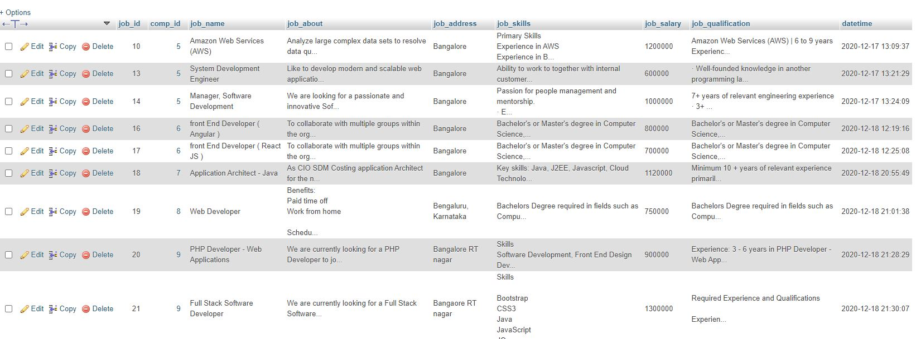

Job DB

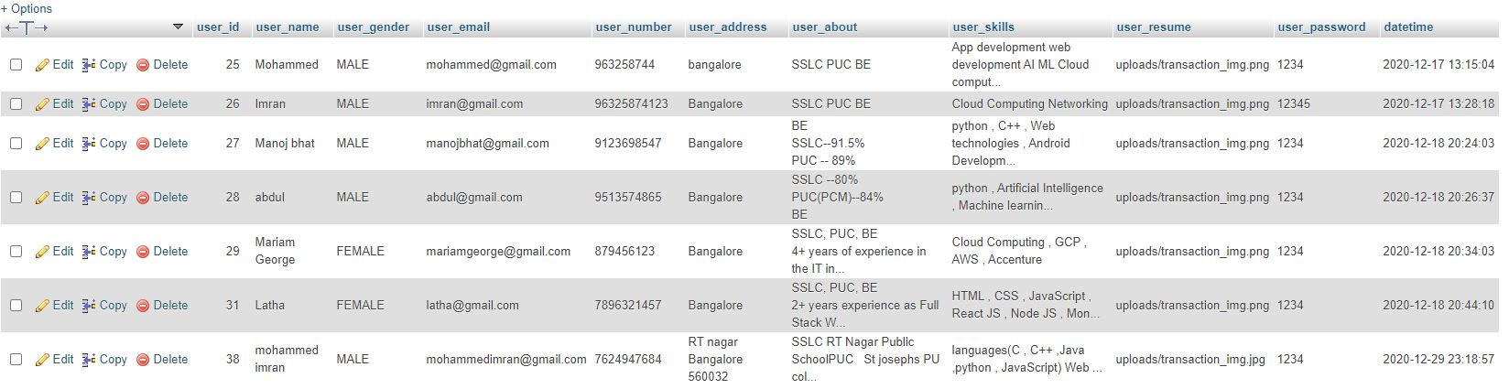

User DB

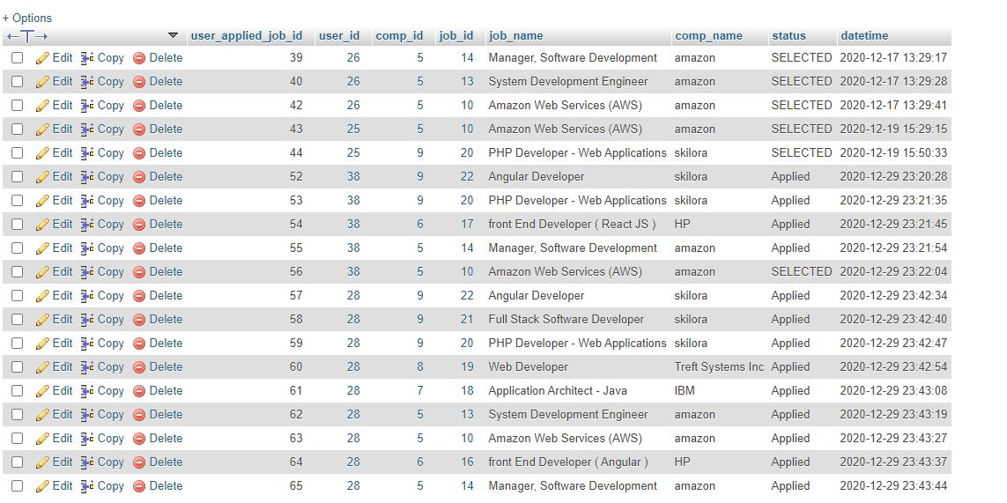

User Applied Jobs DB

**CHAPTER 7**

**CONCLUSION**

The wider areas of job searching facilitate quick and easy access to opportunities. The increasing job opportunities and changing scenario of the business environment today have made more people search for a better career and employers search for a better potential.

This situation has prompted many to move to job portals to look for ways that have been widely accepted and fully useful in job searching. In this sense, the job portals assume greater importance and we could develop such an efficient system that is used by a lot many job hunters and employers.

**FUTURE ENHANCEMENT**

* There is ample scope for enhancement and adding functionalities to this application.
* This application can be extended to send automated interview scheduling through acceptance/rejection of Resume.
* The application can have a job recommendation system based on the frequent search results of different users.
* The portal can also send email notifications to candidates about certain job availabilities.
* There can be a feedback or review section for the application.
* Also unlike the current job description page, users can view the job description on a separate page with one click on the job description.
* The User functionality can be extended to give the user options to save the job and later apply, to upload multiple documents.
* The application can be more scalable by extending the search functionality based on country, city, or area.
* While this application meets the basic requirements of a job portal eliminating a few of the traditional challenges faced like time, money, and effort, it can be extended to make the application more dynamic and robust.
* The User Interface can be made more attractive and user friendly

**BIBLIOGRAPHY**

**WEBSITES:**

<https://developer.mozilla.org/>

<https://www.w3schools.com/>

<https://stackoverflow.com/>

**BOOK REFERENCE**:

Fundamentals of Database Systems, Ramez Elmasri and Shamkant B. Navathe, 7th Edition, 2017, Pearson.

Database management systems, Ramakrishnan, and Gehrke, 3rd Edition, 2014, McGraw Hill